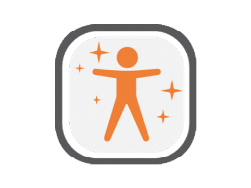
LifeLab+ App Instructions for Teachers

What is it
LifeLab+ is an app designed and built in collaboration with the Serious Games department of Glasgow Caledonian University to introduce and reinforce learning outcomes of LifeLab within the context of an app that students can play on their phones.

It is made to run on Android phones and iPhones.

How do you install it
LifeLab+ is available in the Google Play store and the App store - students should be able to find and install the app by searching for “LifeLab+” on their phone within the respective store for their device (Google Play store for Android, App store for iPhones).

Within your flight case there should be a sheet containing a table of account details, each with a QR code. When running the app students will be prompted to sign in. Students should be provided with the snippet of this sheet that contains their details.

To sign in: Either scan the QR code on the snippet by pressing the button and using the phone’s camera or type the 5 character code in the field and tap to sign in. Some students may have issues with their cameras or simply find it easier to type the code in - Some will prefer to use the QR code.

An internet connection is required to sign in for the first time

To play “Bobbie Saves the World” location permissions and an internet connection is required in order to play this game. The other parts of the app should work without but if these permissions/internet aren’t given by the student (usually when launching the app) then it will not run!

Teacher notes
If your sheet with sign-ins marks ‘Teacher’ on one of the sign-in sheets, then keep this code for yourself and you can use it to check the app and understand the installation process. Our system marks these special accounts and removes them from any sort of data tracking and collection - so a student should not use it.

